

*Subject:* **INTRODUCTION TO SOFTWARE ENGINEERING**

***DETAILED DESIGN DOCUMENT***

**HOTEL MANAGEMENT SOFTWARE**

***Instructor: Mas.Nguyen Thi Thanh Truc***

*Team* **27**

*Name of all member:*

Truong Van Khai – 21520274

Le Ngo Minh Đuc – 21520195

Le Yen Nhi - 21522427

Ngo Phuc Danh – 21521924

*Ho Chi Minh, 1st July 2023*



HO CHI MINH CITY NATIONAL UNIVERSITY

**UNIVERSITY OF INFORMATION TECHNOLOGY**

**SOFTWARE ENGINEERING DEPARTMENT**

**CONTENTS**

1. Hotel Management 3

**1.1.** **Class diagram** 3

**1.2.** **Sequence diagram** 4

1.2.1 Booking room 4

1.2.2 See guest information 4

1.2.3 Check dairy task 5

1.2.4 Check the event 6

1.2.5 Change salary 6

1.2.6 Edit room detail 7

1.2.7 Cancel an event 7

1.2.8 Edit an employee’s task 8

1.2.9 Log into the system 9

1.2.10 Get report of employee’s task 9

1.2.11 Request day off 10

1.2.12 Create employee shift 10

1.2.13 Check employee’s shift 11

1.2.14 Check weekly schedule 11

1.2.15 Create guest account 12

1.2.16 Edit employee’s information 12

1.2.17 Refund payment 13

1.2.18 Request room service 13

1.2.19 Request bill 14

**1.3.** **Screens** 15

1.3.1 List of screeens 15

1.3.2 Screens detail 17

# **Hotel Management**

## **Class diagram**

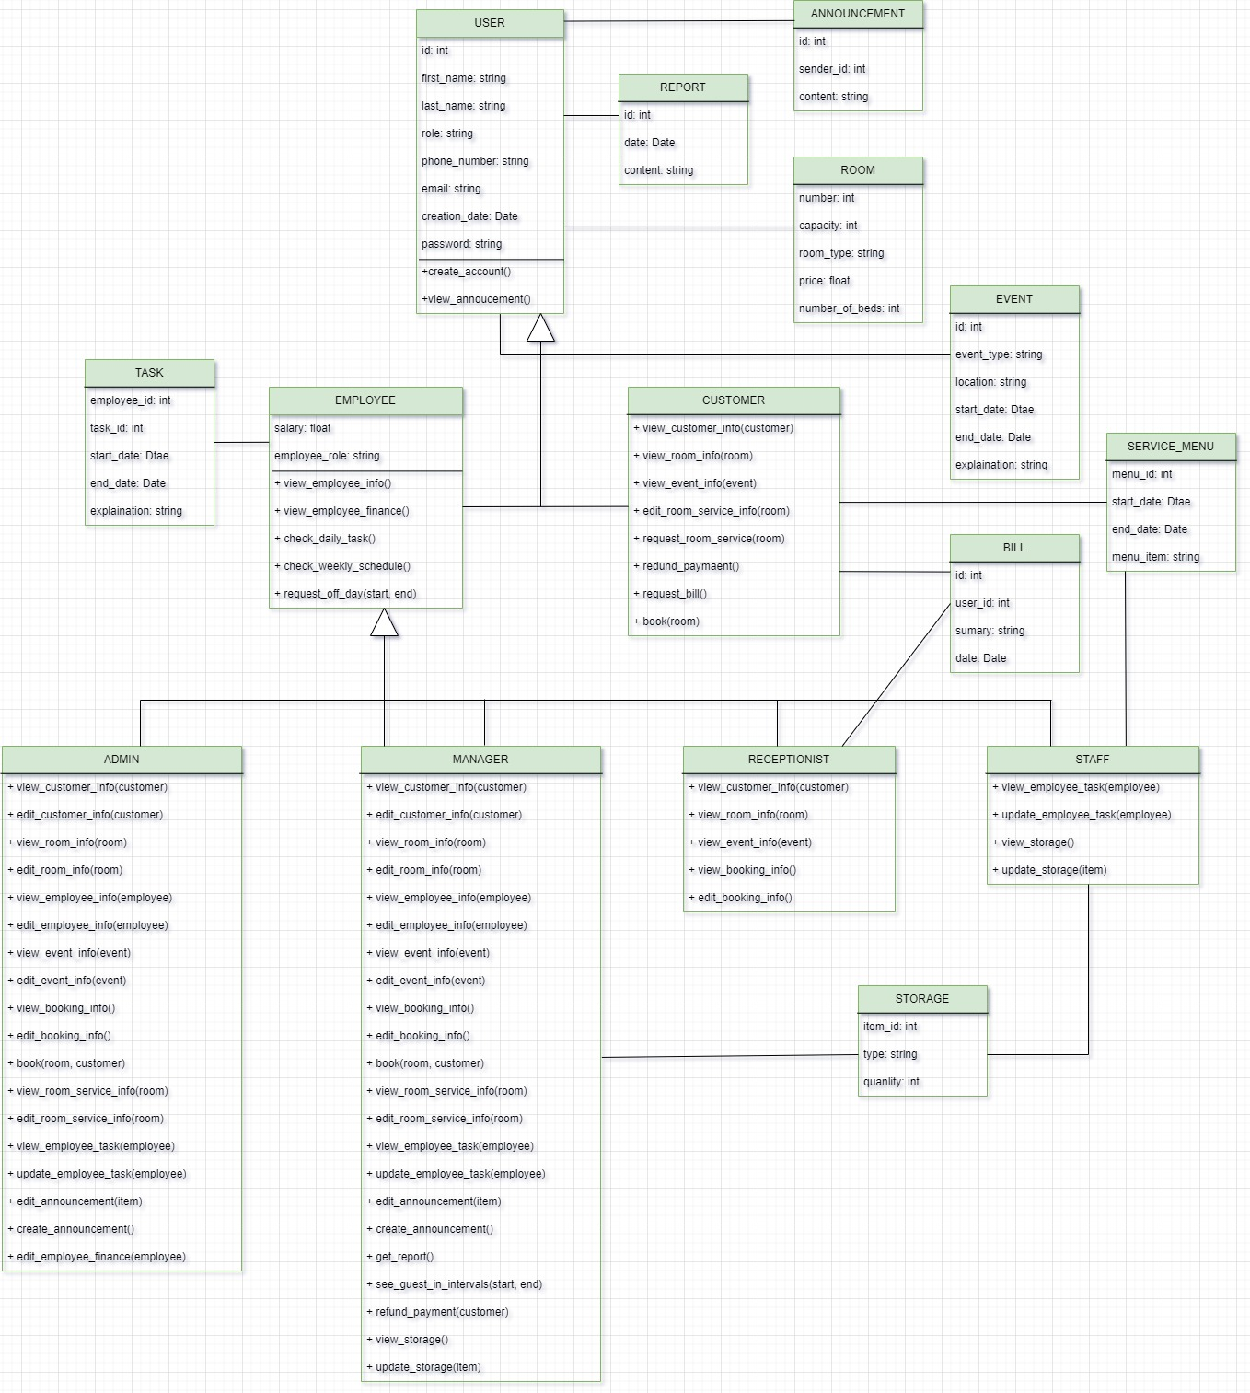

## **Sequence diagram**

### 1.2.1 Booking room

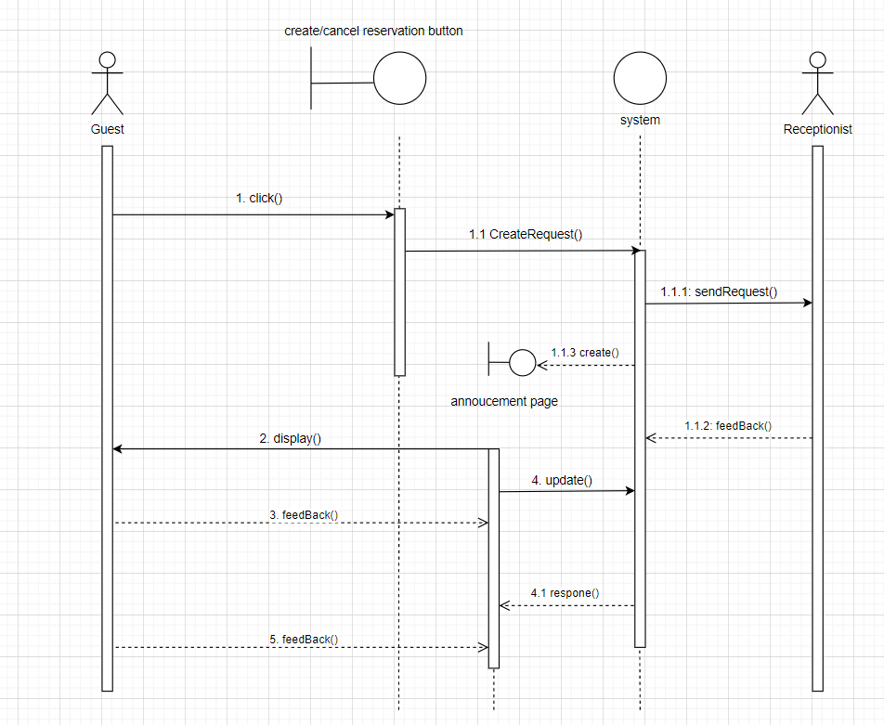

### 1.2.2 See guest information

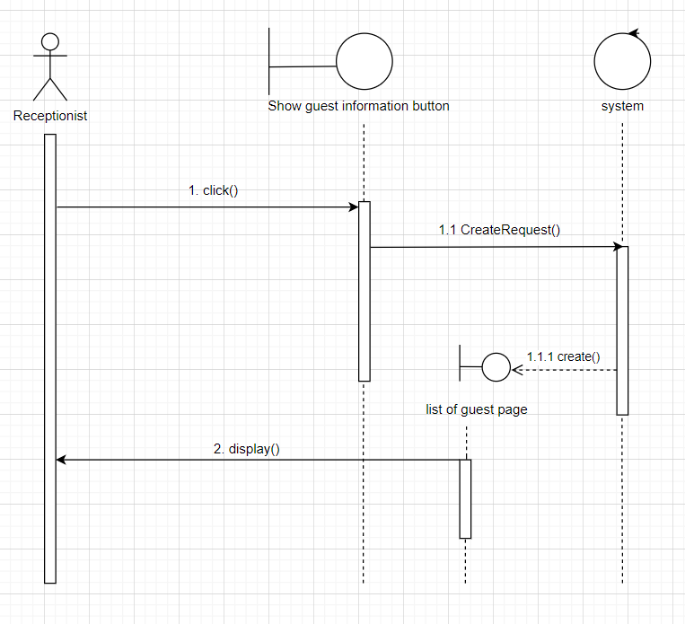

### 1.2.3 Check dairy task

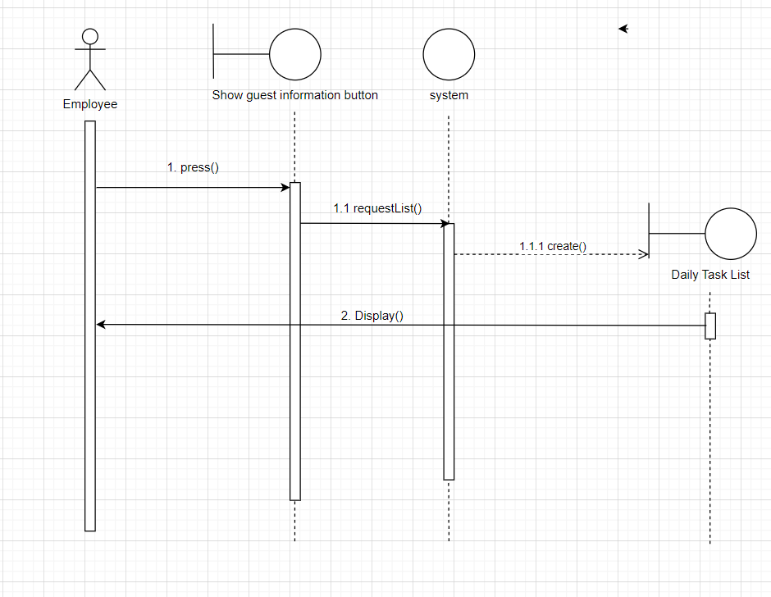

### 1.2.4 Check the event

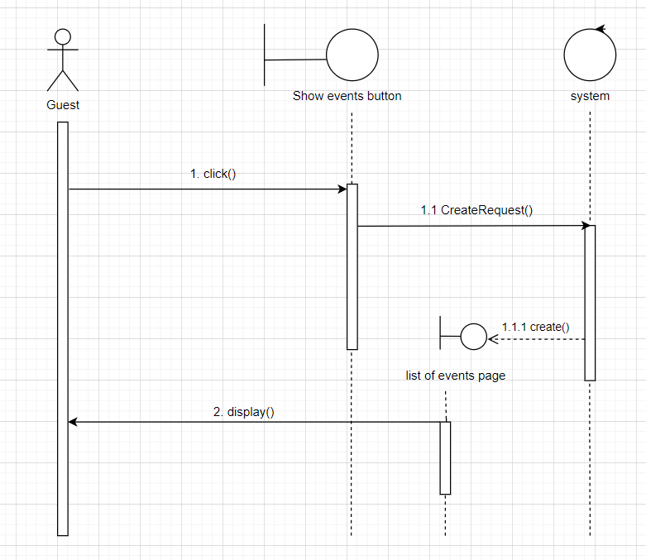

### 1.2.5 Change salary

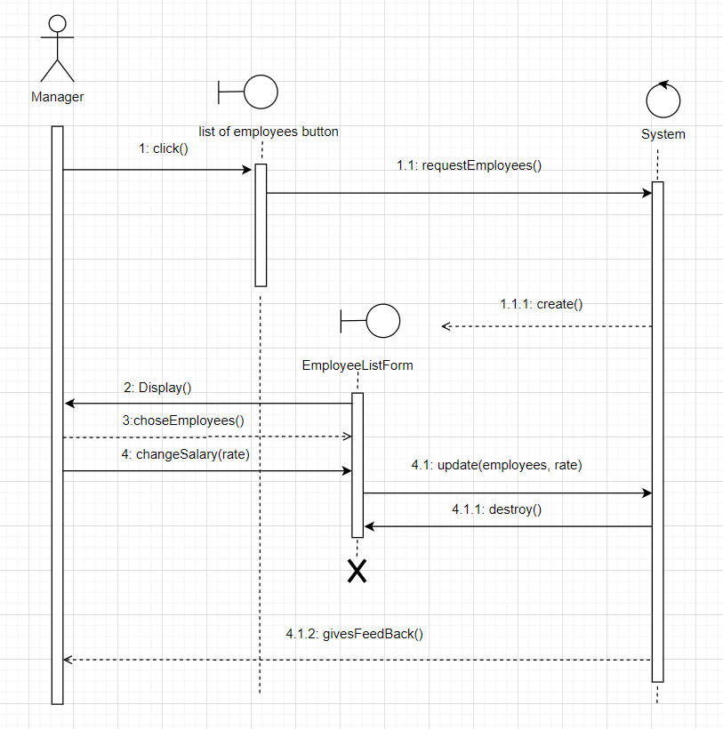

### 1.2.6 Edit room detail

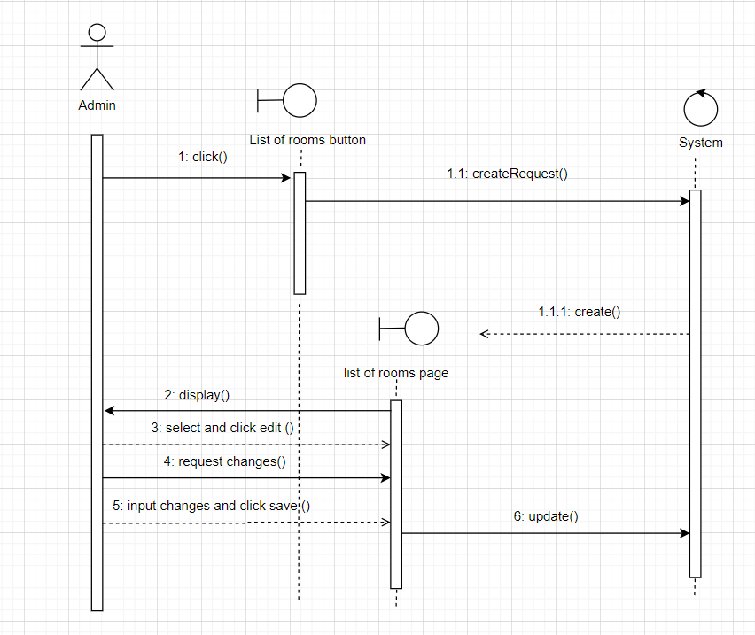

### 1.2.7 Cancel an event

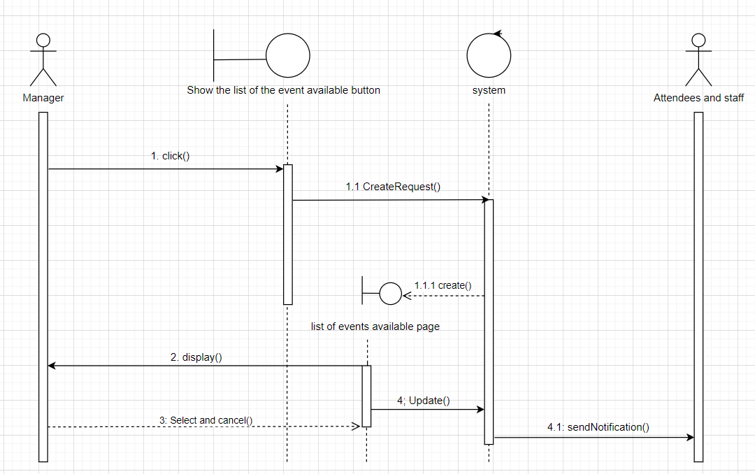

### 1.2.8 Edit an employee’s task

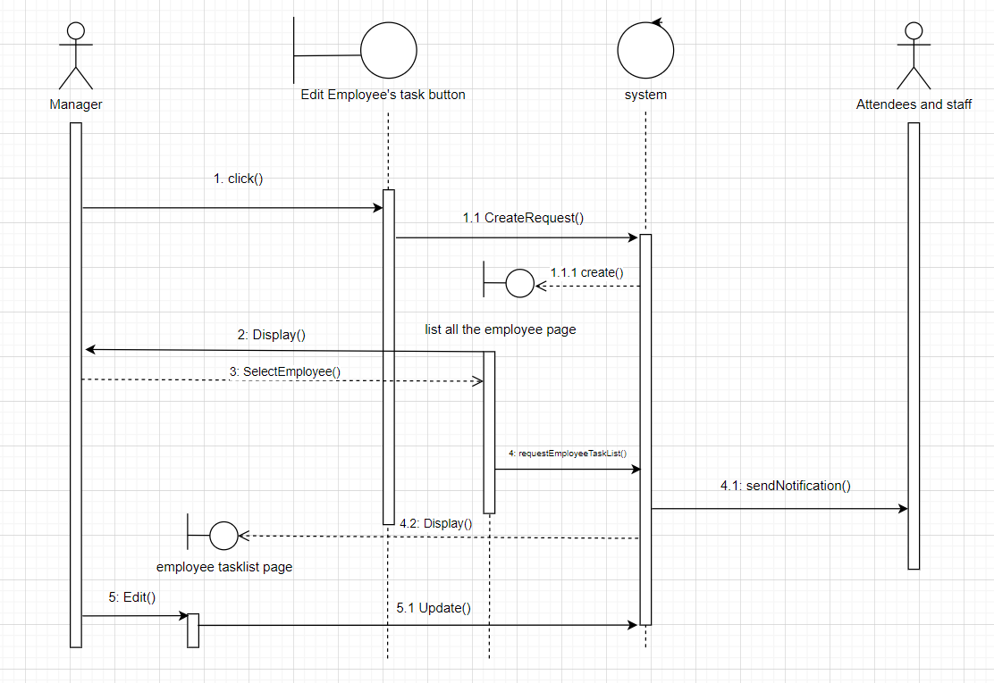

### 1.2.9 Log into the system

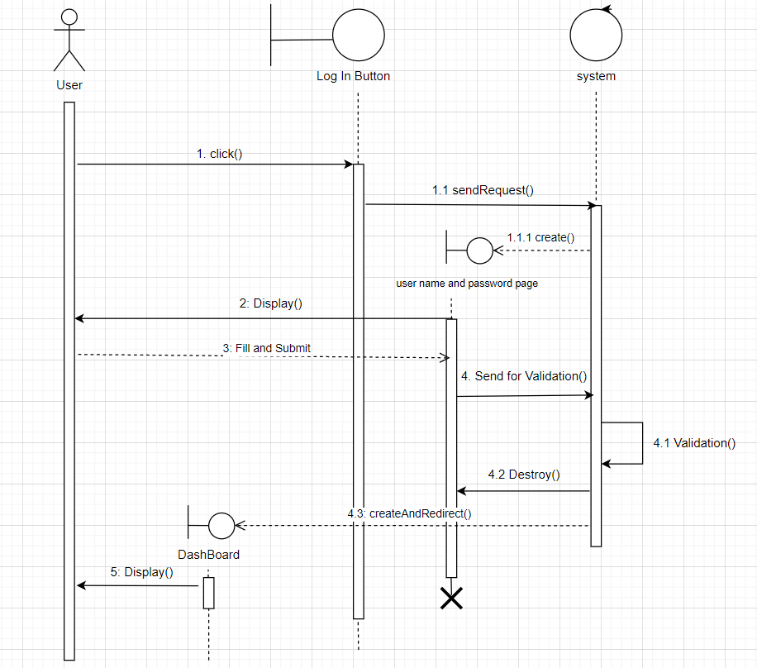

### 1.2.10 Get report of employee’s task

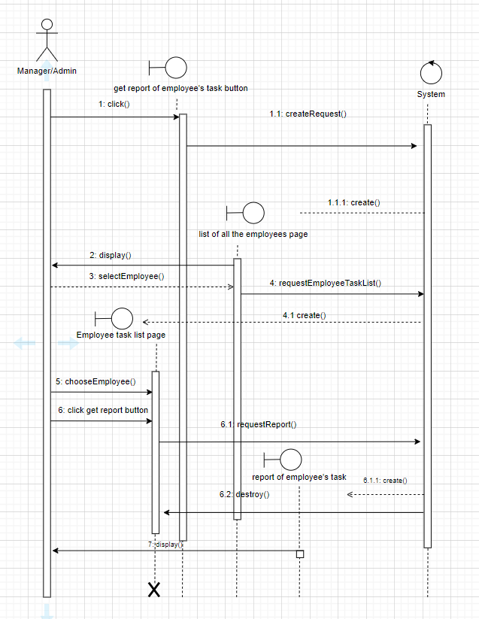

### 1.2.11 Request day off

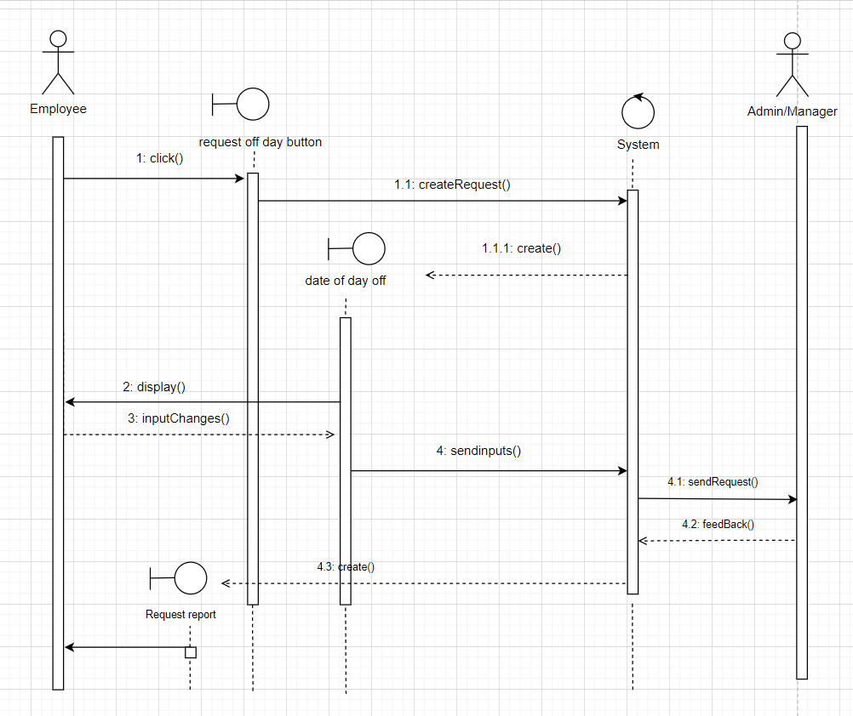

### 1.2.12 Create employee shift

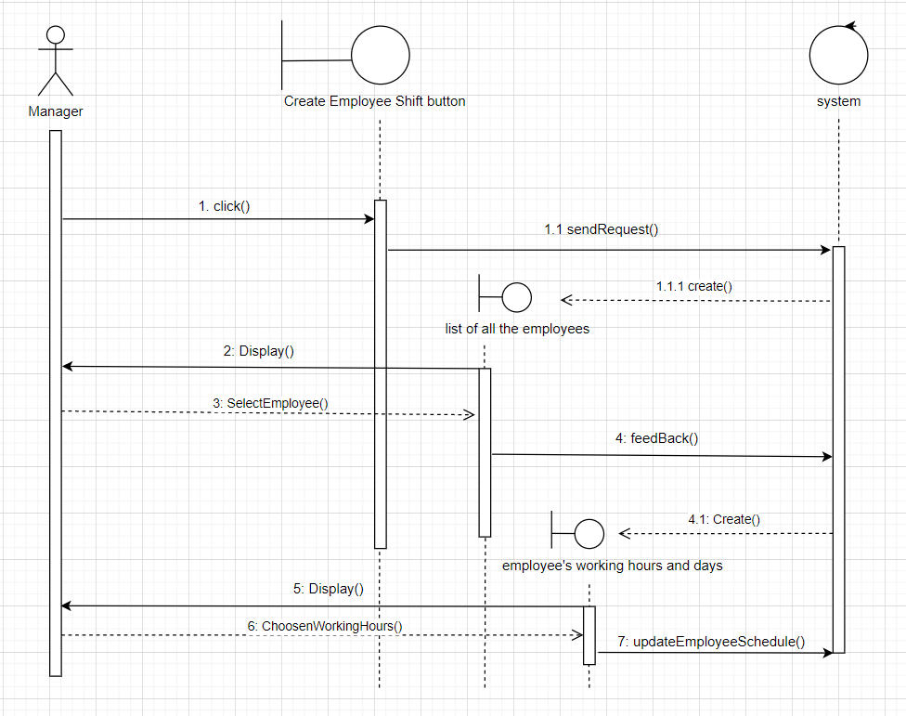

### 1.2.13 Check employee’s shift

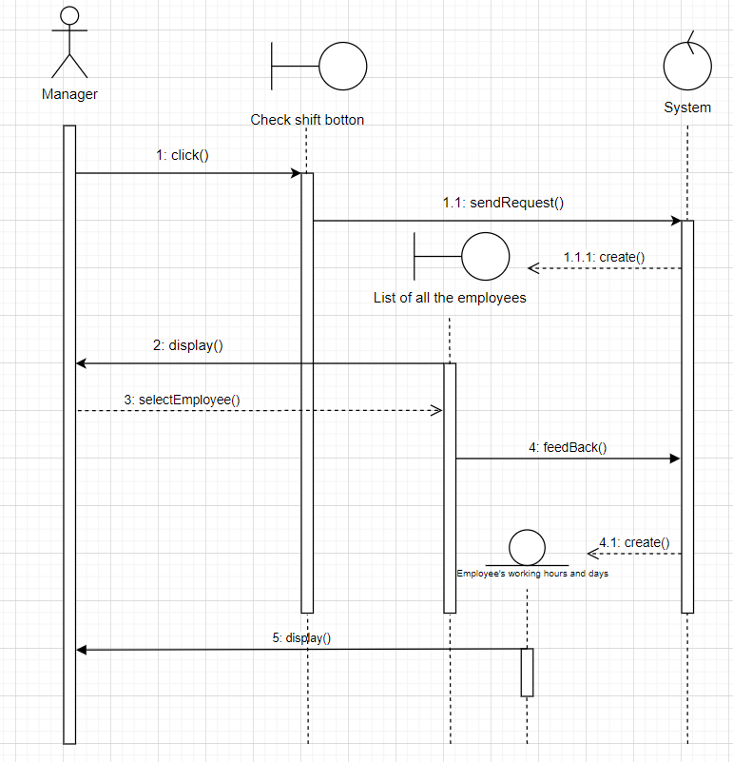

### 1.2.14 Check weekly schedule

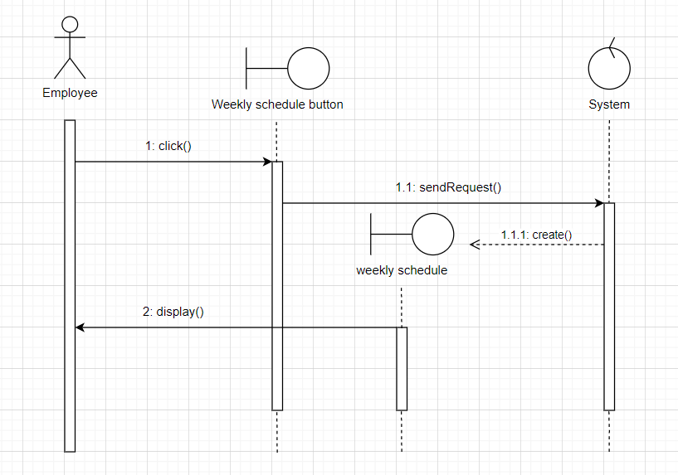

### 1.2.15 Create guest account

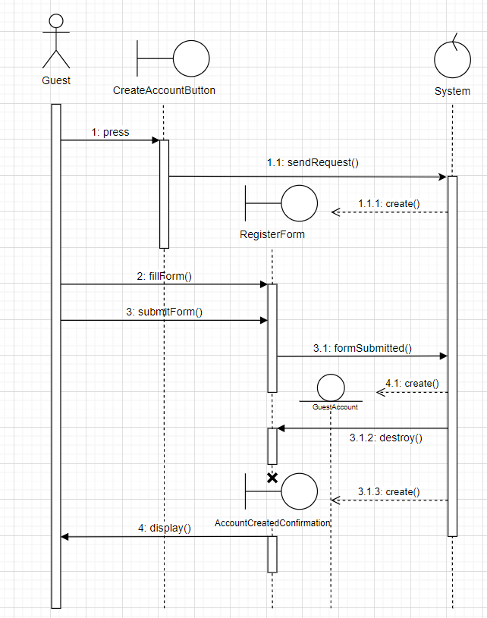

### 1.2.16 Edit employee’s information

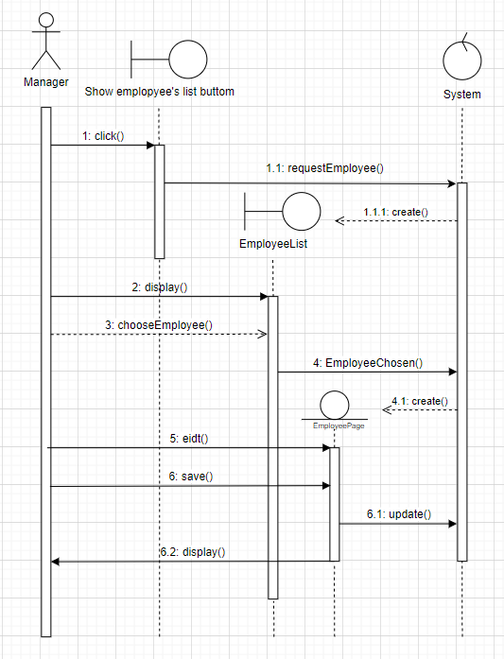

### 1.2.17 Refund payment

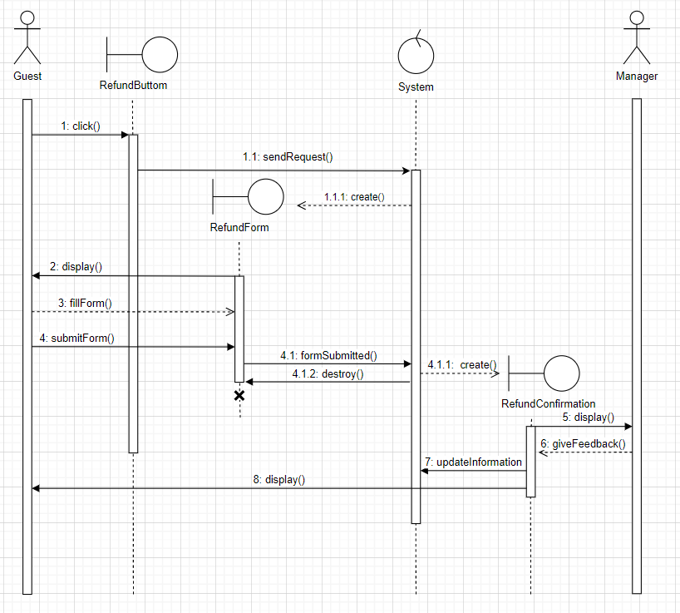

### 1.2.18 Request room service

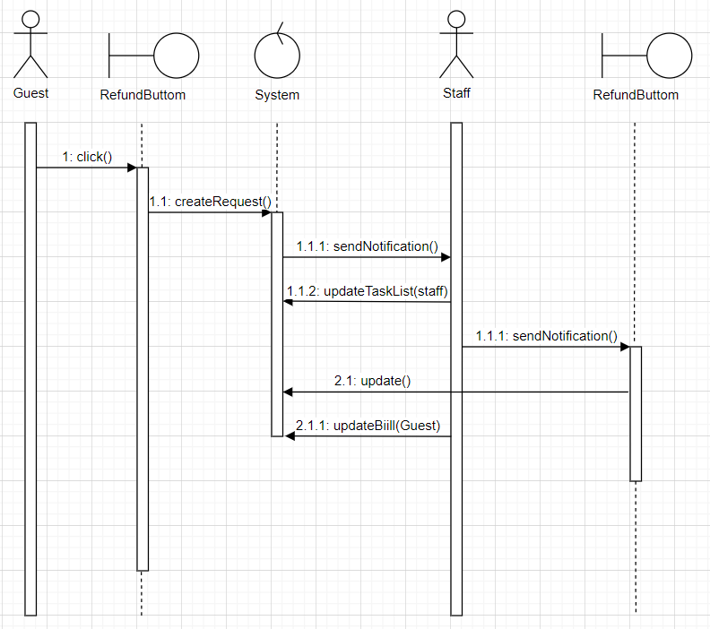

### 1.2.19 Request bill

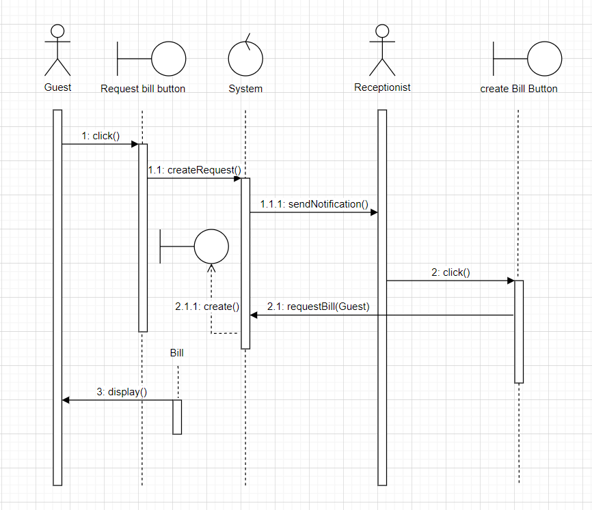

## **Screens**

### 1.3.1 List of screeens

|  |  |  |
| --- | --- | --- |
| ID | Screen | Functionality |
| 1 | Create account screen | Create a new guest account |
| 2 | Login screen | Login into the web |
| 3 | Index (profile screen) | View the profile of the user |
| 4 | Guest list screen | View all guests |
| 5 | Employee list screen | View all employee |
| 6 | Add new employee screen | All new employee to hotel |
| 7 | Event list screen | View all events |
| 8 | Create event screen | Create new event |
| 9 | Booking list screen | View all bookings of customers |
| 10 | Room list screen | View all rooms and let user add new rooms |
| 11 | Add new room screen | Add a new room |
| 12 | Room services screen | View all services |
| 13 | Announcement list screen | View all announcements |
| 14 | Refund screen | View all current refunds |

Screen Flow

1.3.3: Screens detail:

* Create account screen:

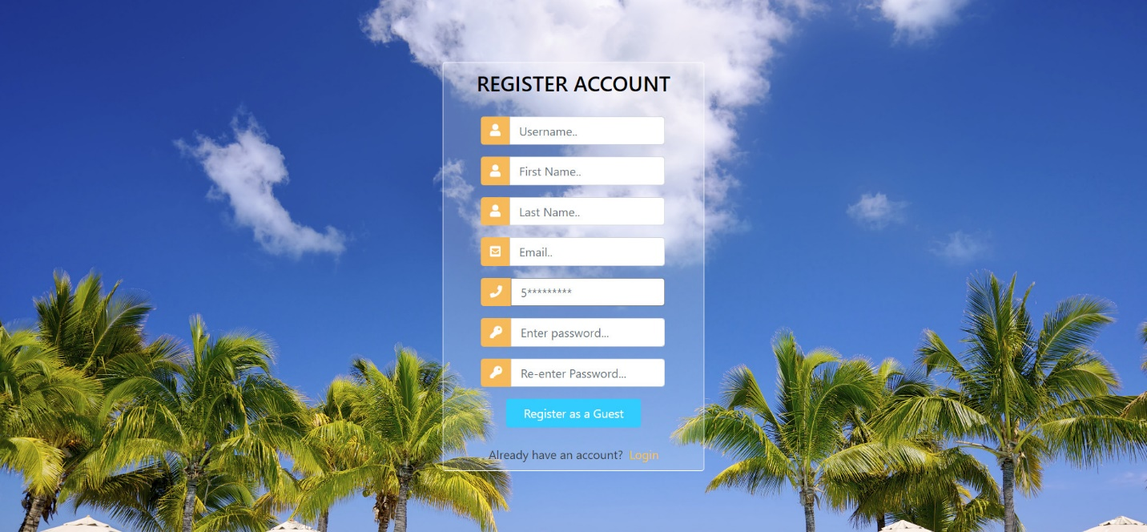

Functionality descriptions:

|  |  |  |
| --- | --- | --- |
| Name | Type | Functionality |
| Username | text form | Input username |
| First name | text form | Input first name |
| Last name | text form | Input last name |
| Email | email form | Input email (if user input is not recognized as a valid email, the system will throw an error) |
| Phone | number form | Input phone number  (if user input is not recognized as a valid number, the system will throw an error) |
| Password | text form | Input password |
| Re-enter password | text form | Retype the password (if this password is not the same as the password above, the system will throw an error) |

* Login screen:

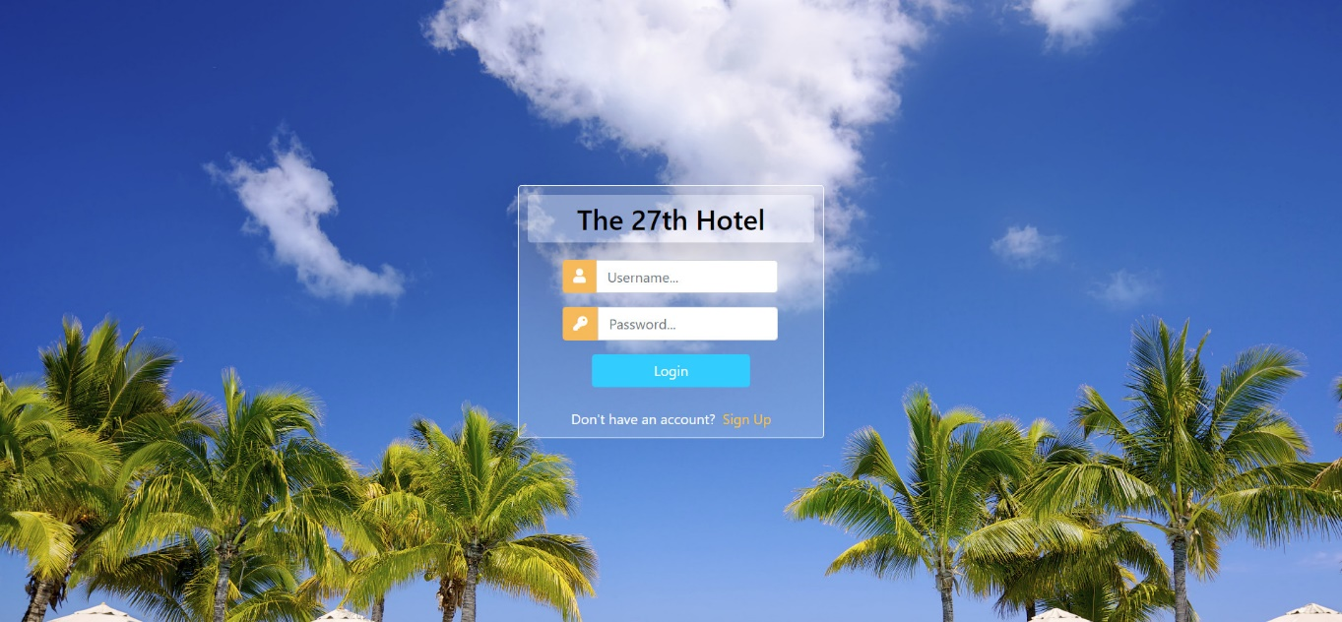

Functionality descriptions:

|  |  |  |
| --- | --- | --- |
| Name | Type | Functionality |
| Username | text form | Check the validity of user’s username |
| Password | text form | Check the validity of user’s password |
| Login | button | Login into the system if username and password are valid |
| Sign up | href | Redirect to Create account screen |

* Profile screen:

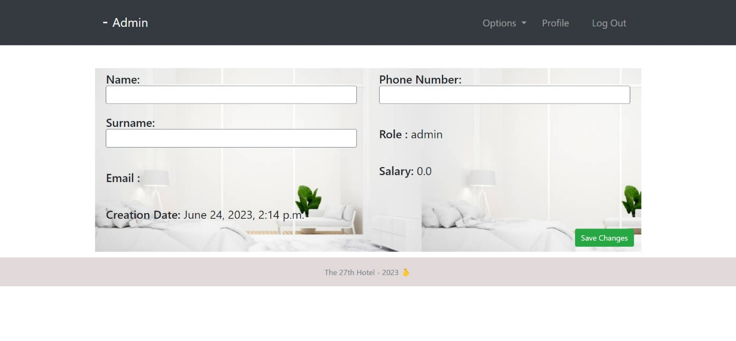

Functionality descriptions:

|  |  |  |
| --- | --- | --- |
| Name | Type | Functionality |
| Name | text form | Write the name of the user |
| Surname | text form | Write the surname of the user |
| Phone number | number form | Write the phone number of the user |
| Save changes | button | Save current changes to the system |
| Options | dropdown list | Move to other screens |
| Profile | href | Move to profile page (this page) |
| Log out | href | Move to login page (log out of the system) |

* Guest list screen:

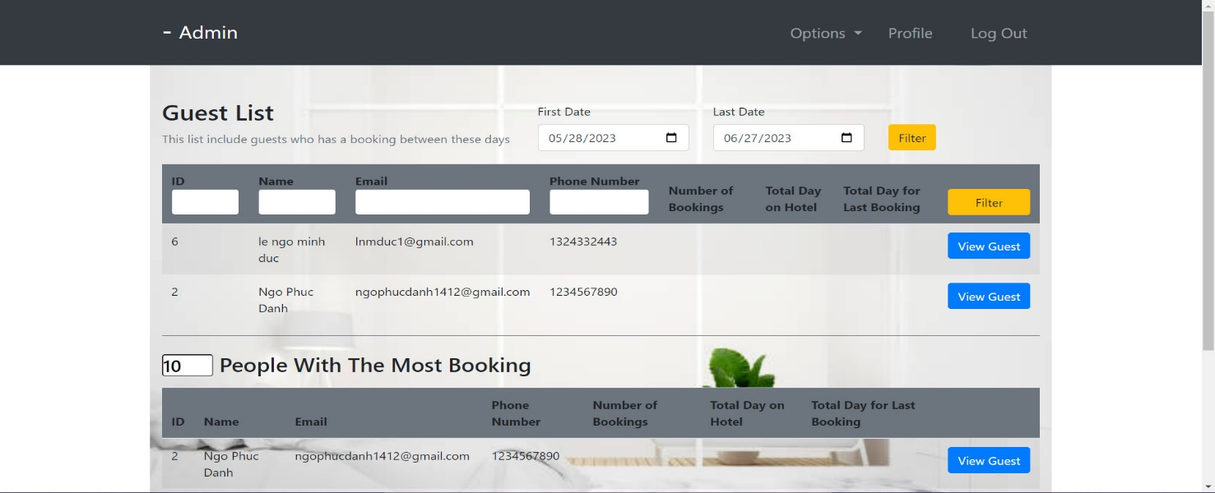

Functionality descriptions:

|  |  |  |
| --- | --- | --- |
| Name | Type | Functionality |
| First date | DateTime | Let the user control the first date of the booking duration of a guest |
| Last date | DateTime | Let the user control the last date of the booking duration of a guest |
| ID | number form | Input id of guest |
| Name | text form | Input name of guest |
| Email | text form | Input email of guest (check validity of this form) |
| Phone number | number form | Input phone number of guest (check validity of this form) |
| Filter | button | filter the guests with the above queries |

* Employee list screen:

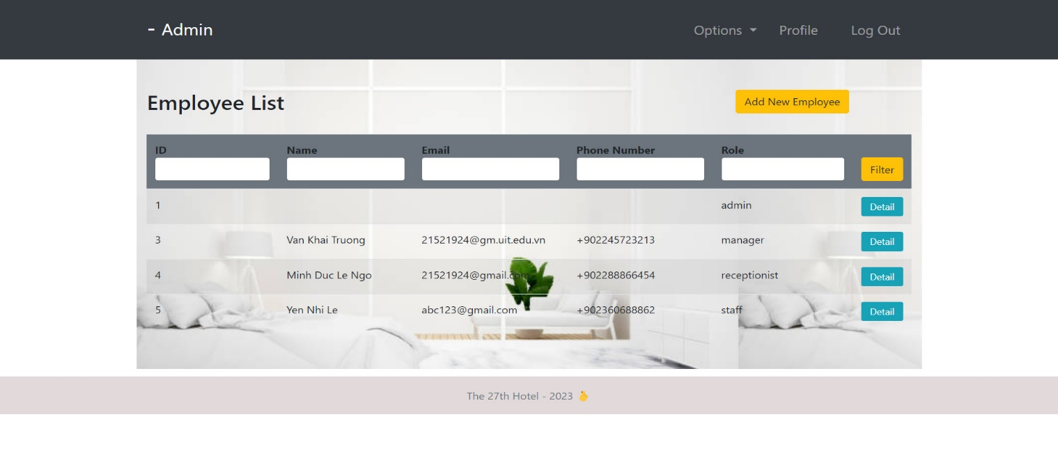

Functionality descriptions:

|  |  |  |
| --- | --- | --- |
| Name | Type | Functionality |
| ID | number form | Input id of employee |
| Name | text form | Input name of employee |
| Email | text form | Input email of employee(check validity of this form) |
| Phone number | number form | Input phone number of employee (check validity of this form) |
| Role | text form | Input the role of employee |
| Filter | button | filter the employee with the above queries |
| Add new employee | button | redirect to Add new employee screen |
| Detail | button | navigate to employee’s profile |

* Add new employee screen:

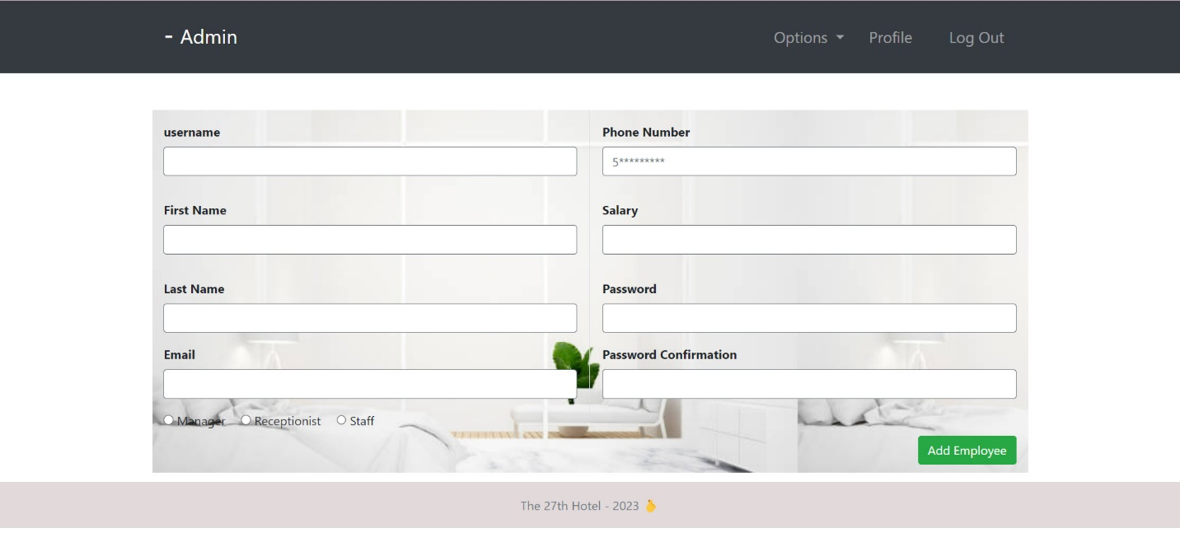

Functionality descriptions:

|  |  |  |
| --- | --- | --- |
| Name | Type | Functionality |
| Username | text form | Add the username of the employee |
| First name | text form | Add the first name of the employee |
| Last name | text form | Add the last name of the employee |
| Email | text form | Add the email of the employee (check the validity of this form) |
| Phone number | number form | Add the phone number of the employee |
| Salary | number form | Add the salary of the employee |
| Password | text form | Create new password for the employee |
| Password confirmation | text form | Reconfirm the password above (check the validity of this form) |
| Add employee | button | Confirm the work and save this employee |

* Event list screen:

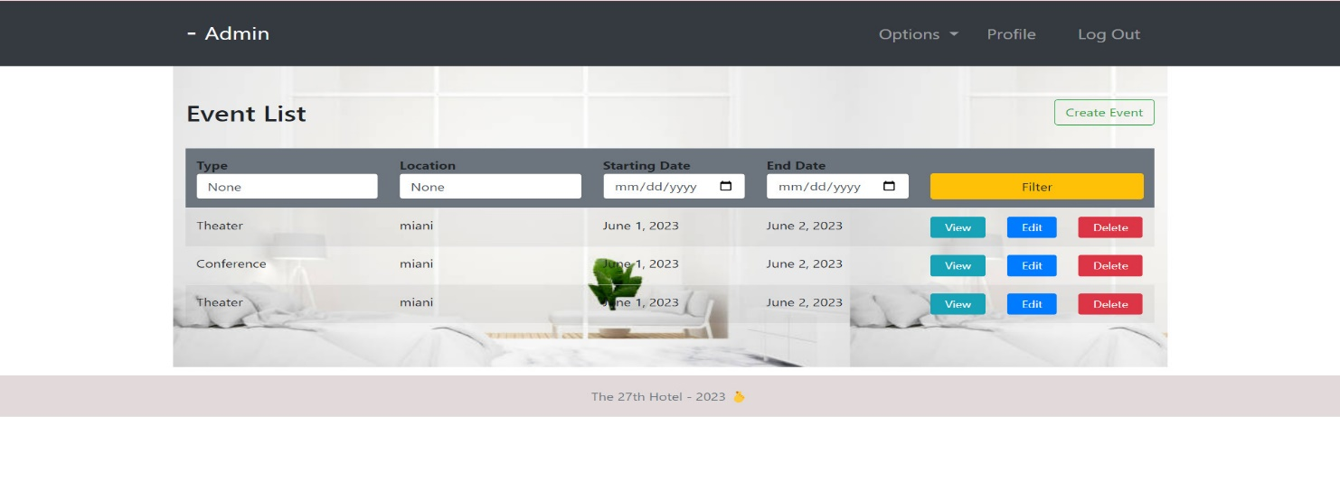

Functionality descriptions:

|  |  |  |
| --- | --- | --- |
| Name | Type | Functionality |
| Type | text form | Input the type of the event |
| Location | text form | Input the location of the event |
| Starting date | DateTime | Input the starting date of the event |
| End date | DateTime | Input the end date of the event |
| Filter | button | filter the event with the above queries |
| Create event | button | Navigate to Create event screen |

* Create event screen:

Functionality descriptions:

|  |  |  |
| --- | --- | --- |
| Name | Type | Functionality |
| Event type | text form | Add the type for the event |
| Location | text form | Add the location for the event |
| Start date | DateTime | Add the start date for the event |
| End date | DateTime | Add the end date for the event |
| Explanation | text form | Add the comments and explanations for the event |
| Save | button | Confirm all changes for the event and save it to the system |

* Booking list screen:

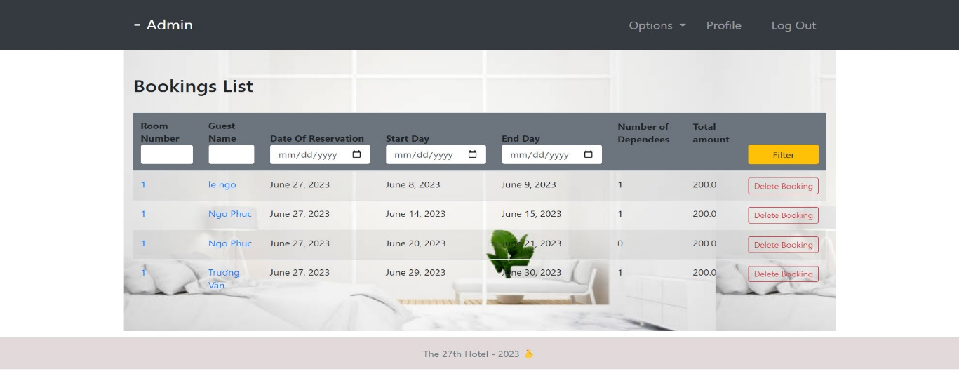

Functionality descriptions:

|  |  |  |
| --- | --- | --- |
| Name | Type | Functionality |
| Room number | number form | Input the number of a room already booked |
| Guest name | text form | Input the name of the customer who booked this room |
| Date of Reservation | DateTime | Input the date that the booking was made |
| Start date | DateTime | Input the starting date of the booking |
| End date | DateTime | Input the end date of the booking |
| Filter | button | filter the booking with the above queries |

* Room list screen:

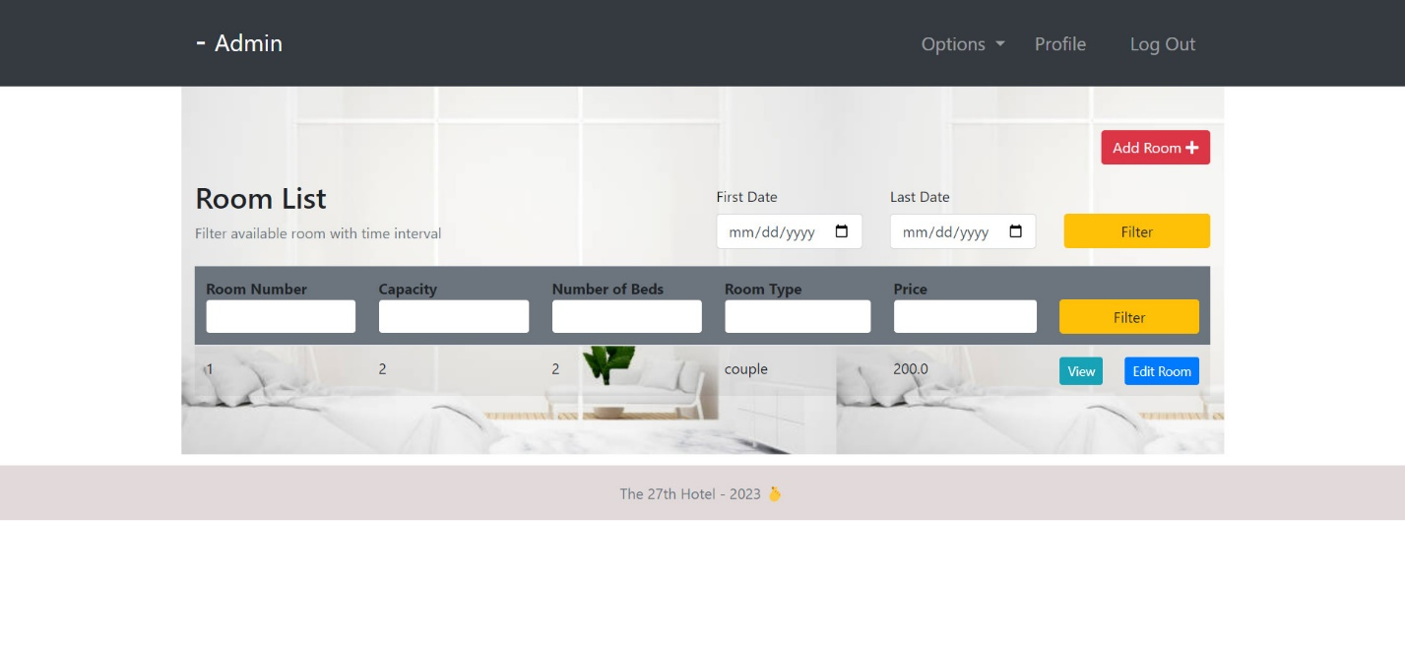

Functionality descriptions:

|  |  |  |
| --- | --- | --- |
| Name | Type | Functionality |
| Room number | number form | Input the number of a room user need to find |
| Capacity | number form | Input the number of people that the room can contains |
| Number of beds | number form | Input the number of beds that the room can contains |
| Room type | text form | Input the type of the room |
| Price | number form | Input the price of the room |
| Filter | button | filter the room with the above queries |
| First date | DateTime | Input the first date of the room being booked |
| Last date | DateTime | Input the last date of the room being booked |
| Add room | button | Navigate to Add room screen |

* Add new room screen:

Functionality descriptions:

|  |  |  |
| --- | --- | --- |
| Name | Type | Functionality |
| Room number | number form | Input the number of a room user need to add |
| Capacity | number form | Input the number of people that the room can contains |
| Number of beds | number form | Input the number of beds that the room can contains |
| Room type | text form | Input the type of the room |
| Price | number form | Input the price of the room |
| Add room | button | Confirm the creation of the room and save it to the system |

* Room services screen:

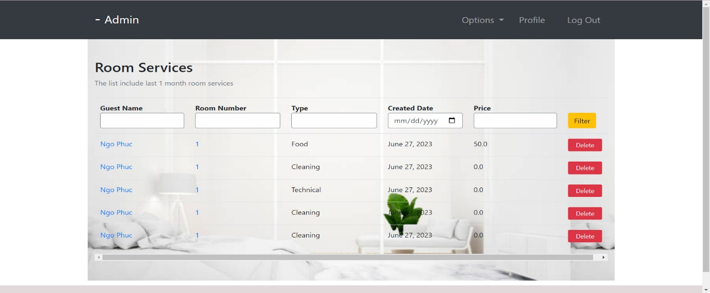

Functionality descriptions:

|  |  |  |
| --- | --- | --- |
| Name | Type | Functionality |
| Guest name | text form | Input the guest name who booked the room service |
| Room Number | number form | Input the room number for the room service |
| Type | text form | Input the type of the room service |
| Created Date | DateTime | Input the created date of the room service |
| Price | number form | Input the price of the room service |
| Filter | button | filter the room service with the above queries |

* Announcement list screen:

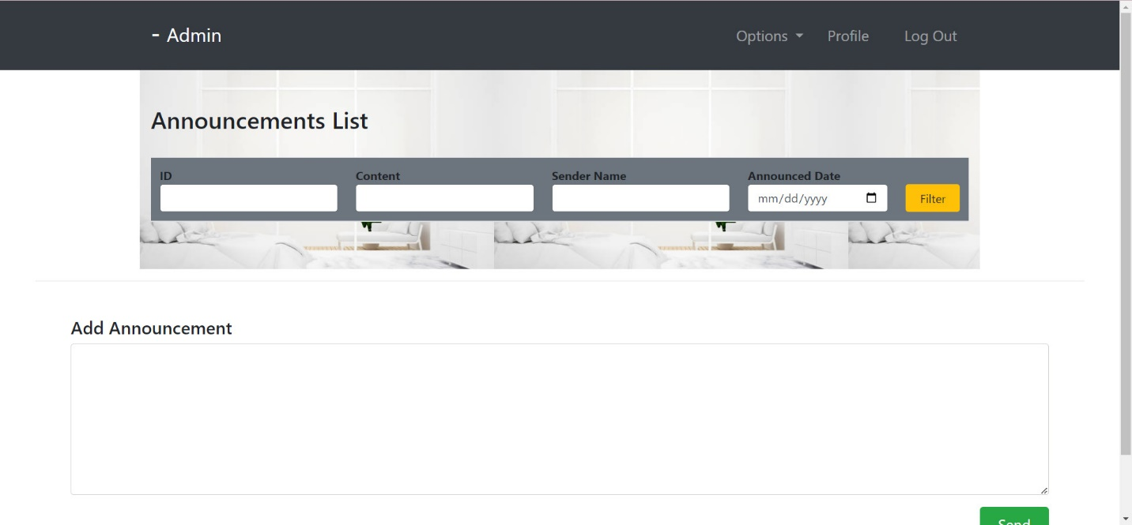

Functionality descriptions:

|  |  |  |
| --- | --- | --- |
| Name | Type | Functionality |
| ID | number form | Input the id of the announcement |
| Content | text form | Input the content of the announcement |
| Sender name | text form | Input the sender name of the announcement |
| Announced date | DateTime | Input the date the announcement was made |
| Filter | button | filter the announcement with the above queries |
| Send | button | send the announcement to all users (to their email address) |

* Refund screen:

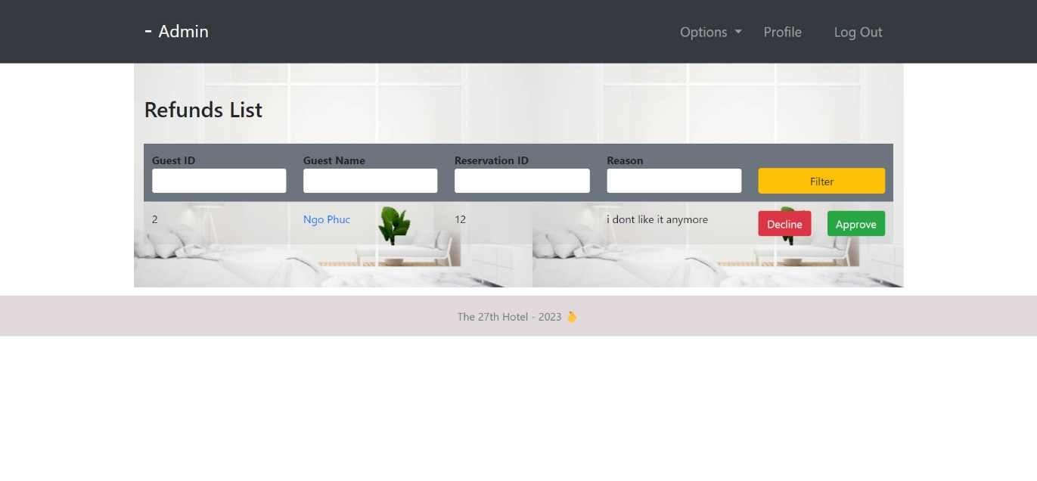

Functionality descriptions:

|  |  |  |
| --- | --- | --- |
| Name | Type | Functionality |
| Guest ID | number form | Input the guest id who made a refund |
| Guest name | text form | Input the name of the guest who made a refund |
| Reservation ID | number form | Input the reservation id |
| Reason | text form | Input the reason of the refund |
| Filter | button | filter the refund with the above queries |